|  |  |  |  |  |
| --- | --- | --- | --- | --- |
| Title | Function | Date | Name | |
| **How To - Writing of user defined tests for CoDIA device type developers** | Author: | 07.09.2016 | Christian Effner | |
| Work Place | Approved by: | 07.09.2016 |  | |
| Developer for CoDIA Device Types | Signature of Approver | | | Date |

Inhaltsverzeichnis

1. Purpose and goal 2

2. Preconditions 2

2.1 Checklist 2

3. How to create Test-Scripts 2

3.1 How to: Creating a Test-Suite 2

3.2 How to: Creating a Test-Case 3

3.3 How to: Creating a Test-Module 3

4. How to use User Defined Test Scripts 3

5. DTMstudio Test 4

6. Historie 5

7. Abbildungsverzeichnis 5

# Purpose and goal

This document is a manual for CoDIA developers. It explains, how to create user defined tests by using CIC DTMstudio Test.

# Preconditions

## Checklist

* DTMstudio Test installed
* TestPackage installed
* DTMstudio Test started
* E+H Device Type Test Project created
* E+H User Defined Test Project created

# How to create Test-Scripts

## How to: Creating a Test-Suite

1. Select folder TestSuites within E+H User Defined Test Projec at Solutions Explorer
2. Open context by right mouse click
3. Select Add -> New Item
4. Select E+H DTMstudio Test Template Test-Suite
5. Add your name of Test-Suite to TS_
6. Confirm selection
   * Test-Suite is shown at Test-Script Explorer as TS_<your_name>.xml
7. Drag created Test-Suite-xml to the upper left corner of the Test-Suite-Configurator
   * A root node is shown, having the same name as the Test-Suite
8. Select a user- or a predefined Test-Case at Test-Script-Explorer
9. Add selected Test-Case via Drag´n´Drop to your Test-Suite within Test-Suite Configurator
   * The selected Test-Case and it´s child elements were added to your Test-Suite
10. Optional: set parameters of unparameterized Test-Cases
11. Rebuild your Solution
    * Test-Suite is shown t Test-Script-Explorer
12. Hint: Modified Test-Suites are saved automatically

## How to: Creating a Test-Case

1. Select folder TestModules within E+H User Defined Test Projec at Solutions Explorer
2. Open context by right mouse click
3. Select Add -> New Item
4. Select E+H DTMstudio Test Template Test-Case
5. Add your name of Test- Module to TC_
6. Confirm selection and configuration
   * Test-Case is shown at Test-Script Explorer as TC_<your_name>.cs
7. Add your specific code to the Test-Case, using functionality from TestFramework or E+H User Defined Test Project. (Please see chapter 8.0 Verwendung des TestFrameworks of the document Getting Started – CiC DTMstudio Test.)
8. Save your user defined Test-Case
9. Rebuild your Solution
   * Test-Case is shown at Test-Script-Explorer

## How to: Creating a Test-Module

1. Select folder TestModules within E+H User Defined Test Projec at Solutions Explorer
2. Open context by right mouse click
3. Select Add -> New Item
4. Select E+H DTMstudio Test Template Test-Module
5. Add your name of Test- Module to TM_
6. Confirm selection and configuration
   * Test-Module is shown at Solution Explorer as TM_<your_name>.cs
7. Add your specific code to the Test Module, using functionality from TestFramework. (Please see chapter 8.0 Verwendung des TestFrameworks of the document Getting Started – CiC DTMstudio Test.)
8. Save your user defined Test-Module
9. Rebuild your Solution
   * Test-Module is shown at Test-Script-Explorer

# How to use User Defined Test Scripts

Any created User Defined Test Script is available at your Test-Script-Explorer, after rebuilding your Solution. You can find your Test-Script below the tree element which is named like your E+H User Defined Test Project.

You can use your Test-Script by adding them via Drag’n’drop to your Test-Script-Configurator or Test-Suite-Configurator.

# DTMstudio Test

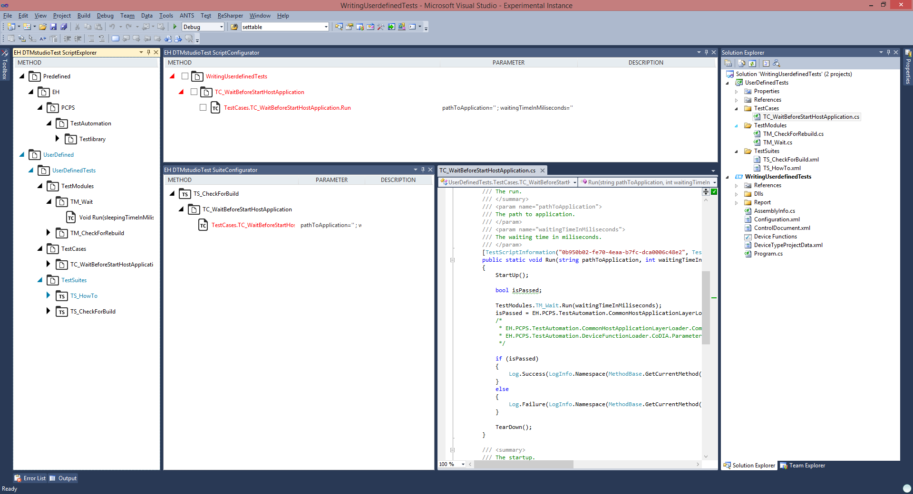

Figure 1: DTMstudio Test

# Historie

|  |  |  |
| --- | --- | --- |
| **Date** | **Person** | **Changes** |
| 2016-08-18 | EC | Initial Version |
|  |  |  |
|  |  |  |
|  |  |  |
|  |  |  |
|  |  |  |

# Abbildungsverzeichnis

Figure 1: DTMstudio Test 4